

TITLE : To study and implement Non-Restoring method of division

AIM : The basis of algorithm is based on paper and pencil approach and the operation involve repetitive shifting with addition and subtraction. So the main aim is to depict the usual process in the form of an algorithm.

______________________________________________________________________

Expected OUTCOME of Experiment: (Mention CO/CO’s attained here)

________________________________________________

Books/ Journals/ Websites referred:

1. Carl Hamacher, Zvonko Vranesic and Safwat Zaky, “Computer Organization”, Fifth Edition, TataMcGraw-Hill.
2. William Stallings, “Computer Organization and Architecture: Designing for Performance”, Eighth Edition, Pearson.

3. Dr. M. Usha, T. S. Srikanth, “Computer System Architecture and Organization”, First Edition, Wiley-India.

_____________________________________________________________________ Pre Lab/ Prior Concepts:

The Non Restoring algorithm works with any combination of positive and negative numbers.

Flowchart for Non Restoring of Division( Students need to draw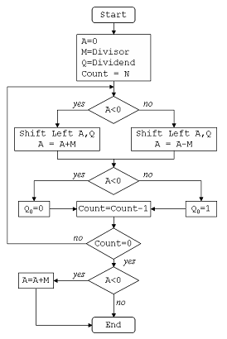

Example: (Handwritten solved problem needs to uploaded)

Conclusion

Post Lab Descriptive Questions

What are the advantages of non restoring division over restoring division?

**Ans:**

Non-restoring division has advantages in terms of efficiency for positive dividends, optimal hardware resource utilization, and simplicity for certain cases. However, as with any algorithm, the choice between non-restoring and restoring division depends on various factors, including the specific requirements of the application, hardware constraints, and trade-offs between different aspects of the algorithm.

**Date: 16/08/2023**